Standard Nonprofit Accounting Format requested by Carol Topp, CPA
For IRS Form 990/990-EZ preparation

I take seriously my responsibility as a CPA to help my clients not just file their annual IRS returns, but to help you better manage your organization and comply with your fiduciary duties of care and compliance.
In order to help you come into better compliance, I encourage you to arrange your financial statements into standard accounting format by following these guidelines.
Statement of Activity (also known as Income and Expenses or Profit and Loss)
- Income (also called Revenues) should be listed by category at the top of the Statement of Activity
- Categories of Income should be the four standard nonprofit accounting categories:
  - Donations
  - Program Income
  - Fundraising Income
  - Misc. Income
Subcategories under these 4 standard categories can be unique to your organization.
- Donations should list individual names (so I can determine is any donor gave more than $5,000 and a Schedule B will be required that lists donors names and address). This can be in a separate spreadsheet or Word document.
- If you use accounting software such as QuickBooks or Aplos
  - There should be no Unapplied Cash Payments
  - There should be no Uncategorized Income
- Expenses will be categorized into four standard nonprofit accounting categories and listed below the Income categories:
  - Program Expense
  - General and Administration Expenses
  - Fundraising Expense
  - Misc Expenses
Subcategories under these 4 standard categories can be unique to your organization.
Some expenses such as Wages and Payroll, should be separated into Program or General & Administrative subcategories depending on what the worker was paid to do.
- Payroll wages should be separated from payroll taxes and payroll expenses (i.e., payroll service fees). Use subcategories for these three categories of payroll expenses.
- If you use accounting software such as QuickBooks or Aplos
  - There should be no Uncategorized Expenses
  - There should be no amounts in Ask My Accountant
- Reports should be in Accrued format especially if you use accounting software and send invoices or collect early deposits of tuition or fees for next fiscal year (i.e. deferred revenue). Cash basis is acceptable if your revenues are under $50,000/year and there are no accounts payable, accounts receivable or deferred revenue (early deposits).
Your Statement of Activity/Income and Expenses should look something like this:
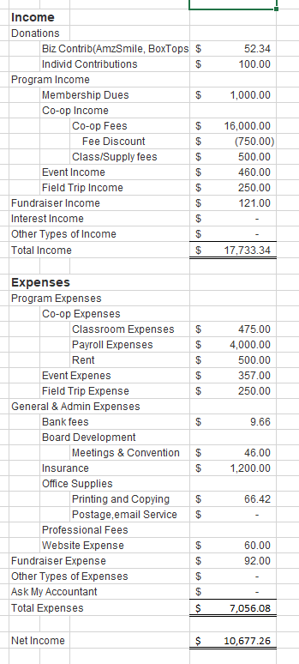
Notice the 4 categories of Income (combine Interest Income and Other Income into Misc. Income) and the 4 categories of Expense (Combine Other Types of Expenses and Ask My Accountant into Misc. Expenses).
The indents and subcategories make the statement easy to read.
Some treasurers will add subtotals, but this report left them off.
The bottom line of Net Income is easy to see
Refund or discounts for Co-op fees are displayed as a reduction in income and are the only negative number allowed on the statement.

Statement of Financial Position (i.e. Balance Sheet)
- Assets listed at the top
  - Income accounts should income all checking, savings, and PayPal/Stripe accounts
- Liabilities listed below Assets
- There should be no negative amounts
- Net Income on the Statement of Activity should match Net Income on the Statement of Financial Position. If not, there are serious errors in your recordkeeping. You will need to hire a qualified bookkeeper and/or QuickBooks expert to make corrections.
Your Statement of Financial Position (i.e. Balance Sheet) should look something like this:
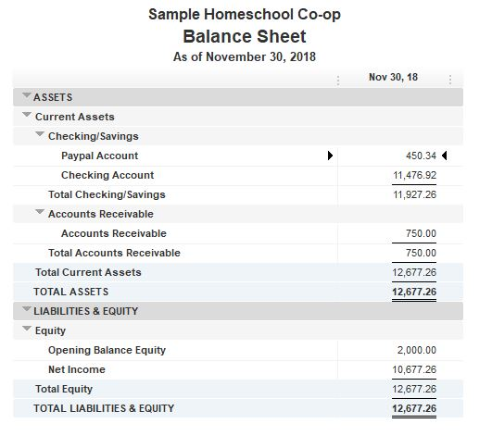

If you have questions about these standard formats, please contact Carol Topp, CPA at Carol@HomeschoolCPA.com
If your financial reports do not comply with these standard nonprofit accounting reports, you may need additional bookkeeping assistance. Carol can give you the names of several bookkeepers and QuickBooks or Aplos experts to assist you.

